Clawson-Youngs Reports 2025:

Environmental Studies Through Various Lenses

Reports Authored by Clawson-Youngs Recipients

Compiled and Edited by

Greta Helfenstein and Brian O’Riley

Foreword by Professor Bill Youngs

Contents

Foreword - J. William T. “Bill” Youngs

Introductions

Liz Briggs - Foxy Cabbage! A Report for the Clawson-Youngs Award in Environmental Studies
Faculty Mentor: Bill Youngs

Sabrina Crawford - Fallout
Faculty Mentor: Rachel Toor

Piper Deakins - The Roommate That’s Not Paying Rent: Invasive Species
Faculty Mentor: Rachel Toor

Austin Havlicek - Bridging the Gap
Faculty Mentor: Kristyne Wiegard

Jerusha Hampson - An Analysis of PFAS Contamination in Surface Waters of the West Plains
Faculty Mentor: Chad Pritchard

Tara Kelsey – Making Environmental Practices Accessible to Immigrants and Refugees
Faculty Mentor: Gina Petrie

Emily Ladd - Five Scars
Faculty Mentor: Rachel Toor

Daisy Roberts - Young Stewards: Scouts in Action for Nature
Faculty Mentor: Rachel Toor

Sarah Rooney - Follow Up Report for Clawson-Youngs Project: Community Hike, Trail Clean-Up, and Open Mic Event
Faculty Mentor: Rachel Toor

Foreword

Several years ago, Alicia Kinne-Clawson and Michael Clawson kindly created the Bill Youngs Endowment at Eastern Washington University. The first project under the endowment is known as the Clawson-Youngs Environmental Studies Award. To qualify undergraduate and graduate students in any field on campus submit a proposal for research on a theme in environmental studies. This booklet consists of the reports written by each of the students on their project results.

- J. William T. “Bill” Youngs

Introductions

The 2025 Clawson-Youngs topics cover an array of subjects which pertain to our environment. The reports vary in scope but there is a through-line that links each of these environmental projects together. They are well-researched and delve into an area of the natural world.

Liz Briggs explores sustainability through her Foxy Cabbage YouTube channel, where she presents practical strategies for individuals and households to reduce waste and improve health, with a special focus on affordable, accessible changes like eating beans, rice, and neglected local species. Her project highlights the impact of small daily choices on environmental resilience.

Sabrina Crawford investigates the environmental consequences of uranium mining in northeastern Washington, focusing on the legacy of contamination at the Midnite Mine. Her narrative blends personal reflection with a sobering examination of the radioactive hazards that persist in local ecosystems and communities.

Piper Deakins examines the threats posed by invasive species, with special attention to personal encounters with the Brown Marmorated Stink Bug and broader impacts on Washington’s crops and ecosystems. The report raises awareness about how both introduced insects and plants disrupt native habitats and challenges readers to take active steps in prevention.

Austin Havlicek’s project links physical wellness with environmental engagement by encouraging participants to connect with nature through hiking and introspective activities. By integrating the Princeton UMatter Wellness Self-Assessment and local conservation resources, Havlicek fosters holistic well-being and stewardship of the Inland Northwest’s landscapes.

Jerusha Hampson studies the spread and effects of PFAS “forever chemicals” in surface waters of Spokane County’s West Plains, tracing sources from firefighting foam usage and wastewater treatment. The research aims to illuminate the pathways and risks of synthetic contaminants in local hydrology and public health.

Tara Kelsey combines her expertise in Spanish for Education and English as a Second Language to create ESL learning activities centered on sustainability for newly arrived refugees and immigrants. Her project strives to make environmental practices accessible from the start, helping newcomers adapt while promoting community health and inclusion.

Emily Ladd reflects on the role of fire in shaping forest ecosystems, using mushroom foraging in the Panhandle National Forest as a lens to explore ecological recovery and personal history. Her project connects wildfire cycles to regional identity and resilience, highlighting how nature and communities respond to adversity.
Daisy Roberts led a Cub Scout Environment Day at Turnbull National Wildlife Refuge, guiding scouts through activities like building solar ovens, making compost jars, and learning about native plants and recycling. Her event emphasized hands-on environmental education and fostered a deeper connection between youth and their local environment.

Sarah Rooney coordinated a community-centered event featuring a hike, trail clean-up, and open mic session, partnering with Spokane Riverkeepers and ConiFriends. The project promoted environmental stewardship and creative expression, with ripple effects that inspired ongoing artistic and ecological initiatives throughout the community.

Liz Briggs

Foxy Cabbage! A Report for the Clawson-Youngs Award in Environmental Studies

Featuring Liz Briggs as Foxy Cabbage
The Foxy Cabbage YouTube Channel (https://www.youtube.com/@FoxyCabbage-o5y) hosts a spread of videos focusing on the nexus of health, nutrition, and personal finance, all with a focus on sustainability. Content is geared toward encouraging viewers to start with “un-revolutionary” actions, and work up from there. The following represents a selection of the videos posted, which focus on ideals of sustainability, and in particular waste mitigation strategies for individuals and households.
- Be Un-Revolutionary introduces the idea of eating beans and rice, for health, for your budget, and for the planet. It’s the most un-revolutionary “tip” imaginable; people do it all over the world! https://youtu.be/Pnx5LNEeGWg
Part one of two. Want to be happy and healthy? Save money and save the planet? The answer is easy. Our parents told us. Our grandparents told us. People around the world do it every day. Be Un-Revolutionary. Eat your beans and rice.
- Be Revolutionary takes this idea a step further, and introduces the idea of eating Neglected and Underutilized Species. It seems like a crazy idea to eat foods we’ve never heard of, but that thrive growing in the climate and neighborhood where we live. Even in our own backyard! https://youtu.be/SdWmP-EFZfU
Part two of two. Got the beans-and-rice part down but feel like there's still something missing? Here's how to change your life by changing your health, and at the same time change the world. Be Revolutionary. Eat Local.
- Four videos showcase a month-long “Puppy Chow-lenge,” in which I ate a diet based around black beans, brown rice, vegetable oil, and iodized salt (a human version of “puppy chow”) for a full month, augmented by the small amounts of food I was able to produce in my suburban home and my small porch and yard.

- Preparing for "Augmenting the Food Basket" April Challenge https://youtu.be/VaE2sVXjBZI
For the month of April I've set myself a food challenge I've dubbed "Augmenting the Food Basket." The idea is based on the World Food Programme Food Basket, and the premise is that I will eat a base layer of cereals & pulses (think "rice and beans"), vegetable oil, and iodized salt, and augment that with only foods that I produce at home. Currently that mainly means quail eggs and microgreens, with other veggies and herbs being present but less reliable! I figured it was a good idea to get some hydroponic strawberries planted quick while it's still early March and I have some possibility that they might begin to fruit by the end of April! My sweet tooth may not abide. Note: In addition to the cereals, pulses, vegetable oil, and iodized salt, I will be adding a multivitamin, as the *actual* WFP foods are fortified!
- The Puppy Chowlenge Day 1 (with Food Math!) https://youtu.be/SVlzdJDN7xM
The day one check in for my month-long personal research study/experiment: The Puppy Chowlenge (fka Augmenting the Food Basket!). I've set myself a challenge based on the ingredients of a typical World Food Programme basket, specifically for my purposes including brown rice, black beans, oats, vegetable oil, and iodized salt. Toppers for my $24-for-a-month base layer of food will consist of anything I can grow at home, including microgreens, sweet potatoes, and tiny quail eggs from my ladies out back. Also planning on some homegrown oyster mushrooms... YUM!
- Puppy Chowlenge Day 15 https://youtu.be/UMv36SdPBvg
Halfway through my month of "human puppy chow with a topper," featuring a daily menu of rice, beans, vegetable oil, and iodized salt, topped with whatever I can grow at home (so far this includes microgreens, Everglades tomatoes, sweet potatoes, mushrooms, green onions, rosemary, and of course quail eggs from the ladies out back). Delicious! It's going well. Except for the oatmeal bit. It turns out I am no great fan of unsweetened oatmeal.
- The Puppy Chowlenge Wrap Up https://youtu.be/BquL2r2klPk
It's the end of a beautiful month of brown rice and black beans. How did it go? Stupendous. Lipids are better, and I didn't even give myself arsenic toxicity. Well... AFAIK, anyway.
- Not Trash, Just Misunderstood https://youtu.be/Zcu03o642j8
What if your garbage isn’t garbage at all? In this episode, we dig into the secret lives of detritivores and decomposers, and how they turn food waste into fertile ground. Learn how BSFL, mushrooms, worms, and compost critters fit into circular, micro-homesteading systems that close the loop and feed the future.
- Feed Your Family, Change the System https://youtu.be/TLeTeYQHK-w
In this episode of Foxy Cabbage, we’re talking about crop diversity: why it matters, why we’re losing it, and how YOU can help bring it back… starting with dinner. You don’t need a farm, a food science degree, or a ton of extra time. You just need to be curious enough to buy (and eat!) something a little weird. We’ll talk about how to find neglected and underutilized species (NUS) at farmers markets, grocery stores, and in CSA boxes—and how these foods can boost your family’s nutrition and support a more sustainable, resilient future. #FoxyCabbage #FeedYourFamilyChangeTheSystem #FoodSecurity #CropDiversity #WeirdVegetables #SustainableEating #CSA #FarmersMarketFinds #FoodJustice #EatLocal #FoodSovereignty #NeglectedCrops #UnderutilizedSpecies #FrugalFood #EatWeird #PlantDiversity #PublicHealthFood
- Trash Talk: The First Full-Length Podcast https://youtu.be/i69ZGBSrRU
Our first full-length podcast! Foxy Cabbage and The Baked Potato talk trash... food waste and plastics recycling, that is! DYK that the USDA estimates 30-40% of food is wasted in this country? Or that plastics recycling rates at a paltry 9% might actually be OVERestimated?! Join us as we talk about washing out yogurt cups before dropping them in the recycling, and about walking that compost out to the backyard instead of letting it turn to methane in the landfill. Note: References "The Story of Stuff" with Annie Leonard. #foodwaste #sustainability #sustainableliving #zerowaste #compost #frugalliving #climateaction

Sabrina Crawford

Fallout

When I first saw it in northeastern Washington, I didn’t know what I was looking at. I knew the Midnite Mine was somewhere in my bird’s eye view, but I wasn’t sure where it was placed in the expanse of nature sprawled before me.
Growing up, I imagined mines as dark veins stretching beneath the Earth’s skin. We humans—vermin—dig and expand those tunnels until nothing precious remains but an exoskeleton of dirt.
This was different.
I wasn’t looking for the aperture of an underground shaft, but a cratered scar in the earth: A pit mine. Now, I can pinpoint the incriminating details: the rock steps down like the great, marbled tiers of the Parthenon, too geometric to be of natural origin. This is not an underground mine from the movies I’d watched as a child. This is a pit mine, the Midnite Mine. And, like the mine itself, its consequences hide in plain sight.
The softwood trees, poking up from the hillsides leading up to the deep, water-filled pits, don’t look sick. Turquoise water gleams from the bottoms of the pits like hidden lagoons. When I first saw them, the water and the trees and the wide backdrop of blue sky working together to form an innocuous picture of inland northwestern beauty, I thought I was just looking at a lake. But these lakes, these trees, and this soil—they harbor secrets.

Fresh out of college and eager to kick off my career, I packed my life into a suitcase and moved two-thousand miles away to Washington. Time off was harder to come by than money for plane tickets. When my close friends from high school announced their engagements, I called to offer my warmest congratulations. I “liked” all the engagement photos.
For one wedding, I knew I couldn’t make it. I gently declined, citing my new job and nonexistent time off. I’d gone home for Christmas to see family and had nothing to spare. Later, I was asked—and gleefully agreed—to be a Bridesmaid for another couple’s wedding. I did the math. I could take a week off next summer.
I did not account for a bachelorette trip a month before the wedding, dress-shopping and fittings, the wedding shower, and other responsibilities. I spent a month worried sick, waffling back and forth on feasibility, and then, finally, made the difficult phone call.
I was relieved that I’d been honest and given plenty of notice. I did it for my own survival.
When the third wedding happened, I was home. The day before, a mutual friend had politely asked if the wedding was my occasion for being in town.
I realized I hadn’t been invited.

Uranium is hot again. In 2025, it’s back in the headlines. Production has tripled. We are touting clean energy and strategic independence. Look at us. We can go nuclear.
We are harvesting the stuff from the deserts of Utah, the mesas of Arizona. There are whispers of re-opening old pit mines here in Washington. We picture this as a new, modern solution to climate change and politely decline to imagine the footprint of our past attempts.

There was so much radioactive material unearthed by the Midnite Mine that it is held, still, in the bark of the nearby trees. The beautiful blue water at the basin of the pits rest on beds of radioactive sludge. Runoff from the mines has infected Blue Creek, Lake Roosevelt, and the Spokane River. It is so bad that state agencies advise against swimming or consuming fish caught in the areas.
Miners went home to their families, uranium residue clinging to their clothes, hair, and skin; delivery drivers with convoys full of uranium scattered ore and dust all over their routes. There is radioactive carnage of the Midnite Mine for miles.
Uranium was a novelty, a piece of the future brought to the contemporary world, a promise of innovation, a hope for a way out of the Cold War. It was crushed up and made into dinnerware, not unlike the use of lead in paint. It is still circulated in antique stores today, proudly on display. Look at this! urge signs taped onto black-light cases. It glows!
The Midnite Mine began operating in the 1950s and came to a halt in the 1980s. Clean-up did not begin until 2015. Even today, a decade later, it’s not finished. “Cleanup” means addressing 40 million cubic yards of contaminated soil and water, and covering the pits.
In itself, it is a massive, 200-million-dollar cleanup plan. It doesn’t even touch runoff in other bodies of water, the toll taken on the Spokane Tribe, or the approximate one in five miners who developed cancer from radiation exposure.
It is an unfortunate part of adult life that there are people whom I hear from daily, and people whom I love dearly, but only hear from once every few weeks. Speaking to the latter inevitably results in both parties pointing to the demands of life—work, relationships, appointments, health—as a reason for being out-of-touch.
When I sent a text to my friends the night of their wedding, wishing them well, hoping they had a magical time, and apologizing once more for not being able to make it, I wasn’t sure if their lack of reply was because they had overindulged in both alcohol and merriment, or if it was a subtle show of disappointment in me.
Still, I kept them, and the rest of my friends, in the back of my mind. I sent birthday texts and liked their Instagram posts when I saw them: weekend trips with their new spouses, pregnancy announcements, brunch dates and Halloween parties.
It wasn’t a sad feeling, but it was melancholy, to realize that I had now become an outsider. That, even if I wanted to go on their next summer vacation, I wouldn’t feel comfortable asking where the next big destination would be. There was no argument which defined this shift; it was attrition. Their presence in my life hadn’t disappeared, but rather leaked away. By the time I realized it, I was already halfway through the fallout.

Environmental reports note the hazards of uranium mining—the same hazards we have brushed off. From 1950 to 1980, almost all uranium mines were located on tribal land, most of which belonged to the Navajo.
In the present, mining operations claim partnership and mindfulness of these tribal lands. One such operation has already formed a partnership with the Navajo which allows them to transport uranium across their ancestral lands. Several others have not stated if their operations will infringe on these borders.

Radiation doesn’t rot like flesh. It stays, like bones bleached by the sun. It decays according to its half-life, which dictates how much time must pass before half of the material is gone. Once it’s been reduced to half, the same amount is required for that half to be reduced in half again, and so on. In two half-lives, a fourth of the material remains.
What is the half-life of uranium? How long will it take to cut the pollution of northeastern Washington in half? Think hundreds of millions of years.
This is not ideal.

It happens with friendships, too. Some don’t end, but simply half-live. The warmth ebbs out with every unanswered text, every social media post not seen. My choices back then were unavoidable, but the fallout was my fault.
I hadn’t meant to hurt anyone. Yet, the effects of my actions revealed themselves over time. It’s too late for me to clean up the mess I made. The absence remains, a hollow pit within me.

As we push forward with uranium mining, seeking new mining sites and reviving old ones, what will we do differently? When our past actions have consequences which effect not only ourselves, but those around us, how can we learn from them and move forward?
We have the opportunity to acknowledge that we have tried this before and made mistakes, to work with the land and the communities who will bear the brunt of extraction. We can find a compromise that is more than a forced hand behind a veneer of diplomacy.
Are we up to the task?

Piper Deakins

The Roommate That’s Not Paying Rent: Invasive Species

It was just this last winter when I awoke in the middle of the night from an otherwise entirely peaceful slumber to the feeling of a sickening crunch in the palm of my hand. My fist tightened in confusion, feeling six little legs twitch, and the crisp sensation the hard outer chitin gave under the pressure. From the haze of sleep, I wasn’t sure what misfortune had befallen me until the intense, cloying scent of oversweet rotting green apples hit my nose. What my sleeping body had thought to be an innocent itch was, in fact, the manifestation of pure evil, a Halyomorpha halys (Brown Marmorated Stink Bug or BMSB). It had, along with hundreds of its siblings, invaded my house for the colder months, and more importantly, had interrupted my REM cycle.
I screamed— a completely reasonable response to the situation at hand— and threw the offending creature to some unknown corner of my bedroom. This was a mistake I would soon regret when I later couldn’t find it at all and spent the night in a state of over-tired paranoia. The lingering aroma was the only indication that it hadn’t been a dream. The scent of a stinkbug, if you have never had the great pleasure of smelling it, lingers up to a full day in some cases. There was no chance I would be getting back to sleep in my bed anytime soon.
This bug, a physical manifestation of all that's wrong, winters in your home and invites every other bug like it to join the party. If you have a shed, no, you don’t; it’s their shed until the following spring. Their haphazard and erratic flight will entangle them in your hair. Their easily spooked nature will infuse your clothes and pillows with their signature stink. They have a long lifespan for a bug. And their numbers continuously rise with each summer, introducing two new generations into the mix.
While my vendetta against the pest is well-warranted by this incident alone, there is a much more serious reason to dislike these bugs. According to the Washington Invasive Species Council WISC, the BMSB is an invasive species native to East Asia that has now been found in 29 of the 39 counties in Washington. Without any more information, already this is worrying for the general goal of maintaining our ecosystems; however, it goes much deeper than this, as they are detrimental to crops. They are by no means picky about what they destroy. The WISC reports that they target over 170 different species, and the crops that they target are left behind with discoloration and necrotic spots that make the product inedible.
In Washington, the BMSB is still more of a nuisance than a serious threat at this point, but all one needs to do is take a look at the East Coast and their significantly more intense situation with the pests to see how much damage these insects can do. Stop BSMB, an organization built to inform the public about the invasive species, stated, “In 2010, the invader caused catastrophic damage in most mid-Atlantic states, with some growers of sweet corn, peppers, tomatoes, apples, and peaches reporting total losses that year.”(Origins of BMSB).
I’ve always known, in the back of my mind, the danger posed by invasive species. At some point in elementary school, maybe on Earth Day, I was made aware that our environment didn’t look exactly how it was supposed to. Along the way, I figured out that invasive species have the ability to harm our environment and eliminate native species. I also, without realizing it, decided not to think about it beyond that. There was a level of apathy I felt, like there was nothing to be done. Learning about the invasive nature of the bug I despise lit a flame within me to consider the seriousness of this issue. While caring about the problems that directly affect my life isn’t wrong, it’s also not enough. Unbeknownst to many, there are so many other invasive species affecting our home and our environment daily.
In the third grade, we had a middle of the year concert. All of the classes got on stage and sang a couple of songs while our parents watched, their faces displaying every emotion from awe to abject boredom. I remember our music teacher, in a sense of civic pride, had us singing Washington-themed songs. Two of those songs had to do with apples. One was a cute little tune going through every variety of apple. The other, a clever use of an agricultural road sign warning of the dangers of transporting homegrown tree fruit. Or more honestly, a road sign that she had somehow decided to put a beat to and have us repeat over and over. I have to admit, though, she had written a catchy tune that left a lingering message. To this day, when driving past a sign stating “apple maggot quarantine area, do not transport homegrown tree fruit,” I can’t help but start to sing. It's funny how one of our most prevalent invasive species made it into a song I sang at nine years old.
Apple Maggots pose a serious threat to many fruit crops, not just to apples. Like the song directly states, Washington has already taken action for some time in containing this particular pest. There are quarantines in place to keep out the maggots and monitor the areas in case any happen to get in. The Washington State University Tree Fruit Site says that Apple Maggot control can be particularly hard for organic orchards, as not many approved insecticides work on them. The more awareness we have of invasive species like this, the more we can do to prevent the problems that come with them.
Invasive species don’t just come in the form of creepy-crawlies, but also in all areas of flora and fauna. The WISC has 26 plants to keep an eye on, 16 invasive animals, and Apple Maggots and BMSB make up only two of the 13 priority species of insects that make up their list. Many invasive species are introduced through the movement of goods across borders, often hitching rides on cargo shipments from other countries or states.
The demand for unique plants and the competitive gardening needs of the suburbs seem to play a significant role in the spread of invasive plants. The species will be introduced for decorative purposes, to later overwhelm the native plants in the ecosystem. An example of this is the Butterfly Bush, which, while beautiful, works hard at displacing the plants around it. In “The Truth about the Butterfly Bush (And What to Plant Instead!)”, It shares how the Butterfly Bush destroys local pollinators and does the opposite of what its name suggests, and is harmful to butterflies long-term.
Unfortunately, one of the main reasons for invasive animals is irresponsible pet ownership. Animals are commonly displaced or abandoned, whether intentionally or accidentally. The African Clawed Frog and Bullfrog serve as prime examples of this issue, as noted by the WISC. Both of these frogs are very aggressive toward native species. People don’t consider the ramifications if the animals do survive in the wild.
There are steps we all can take to do our part. We all can make sure to check our shoes when we travel to and from new places. If you have a hike planned, give your boots a good brush down before and after visiting a new trail. When you’re at the beach enjoying a hot day on Silver Lake, make sure you rinse your kayak with a hose before dipping that same boat into the crystalline waterfall at Horseshoe Lake. The Don’t Let It Loose website is a wonderful resource to help lead people to the appropriate places to rehome pets without releasing them into the wild, with state-by-state guidelines. If you have a particular passion for destroying the dastardly insect that is the BMSB, like me, I have a tip for you as well. Setting off a stinkbug doesn’t bring others swarming to their scent; that's an old wives' tale. Don’t be afraid to kick them out of your house and room, hopefully with more success than I. There is so much that everyone can do; even the smallest of actions can mean something big.
The world is in a tumultuous time. With this age of information and social media at our fingertips, there are so many problems to champion and so much decision fatigue on what the right thing to do is. I know stinkbugs might not be the foremost issue on everyone's mind. At a glance, many of the invasive species I mention today seem benign, but they are far more insidious than they first appear. The National Wildlife Foundation says, “Invasive species are among the leading threats to native wildlife. Approximately 42 percent of threatened or endangered species are at risk due to invasive species.”(Invasive Species). The scale is so much larger than I first thought, and I hope my realization can help others feel the same. Invasive species affect our crops, our economy, our ecosystem, and animals, and of course, they affect my slumber.

Works Cited
“Brown Marmorated Stink Bug.” Washington Invasive Species Council,
Washington State Recreation and Conservation Office, invasivespecies.wa.gov/priorityspecies/brown-marmorated-stink-bug/. Accessed 27 June 2025.
Brunner, Jay. “Washington State University.” WSU Tree Fruit | Washington State
University, Washington State University, June 2016, treefruit.wsu.edu/crop-protection/opm/am-control_waapple-growers/.
“Exotic Pest Detection.” Exotic Pest Detection, Washington State Department of
Agriculture, agr.wa.gov/departments/insects-pests-and-weeds/insects/exotic-pest-detection. Accessed 15 May 2025.
“Invasive Species.” National Wildlife Federation, NWF,
www.nwf.org/Educational-Resources/Wildlife-Guide/Threats-to-Wildlife/Invasive-Species. Accessed 20 May 2025.
LaVaute, Kelly. “The Truth about the Butterfly Bush (and What to Plant Instead!).”
Garden for Wildlife, National Wildlife Federation, 31 May 2022, gardenforwildlife.com/blogs/learning-center/why-to-avoid-butterfly-bush?srsltid=AfmBOor_K1n6pTaCKmNHigP8PeyB92EN5eUNUiJoKcM6gAM4YDul14CX.
“Origins of BMSB.” StopBMSB.Org, Stop BSMB,
www.stopbmsb.org/stink-bug-basics/origins-of-bmsb/. Accessed 18 June 2025.
“Priority Species.” Washington Invasive Species Council, Washington State
Recreation and Conservation Office, 15 Aug. 2019, invasivespecies.wa.gov/find-a-priority-species/.
“Promoting Responsible Pet Ownership.” Don’t Let It Loose, US Fish & Wildlife Service,
www.dontletitloose.com/. Accessed 18 June 2025.

Austin Havlicek

Bridging the Gap

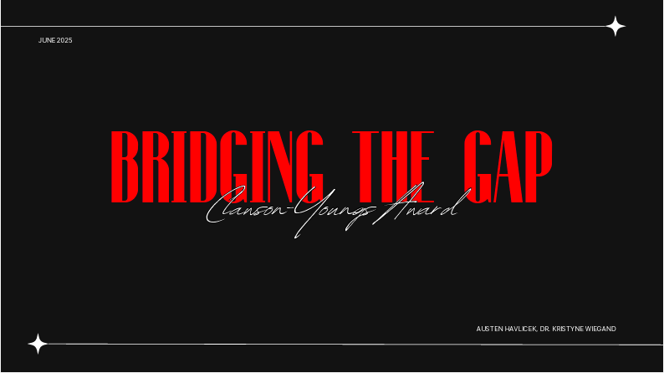



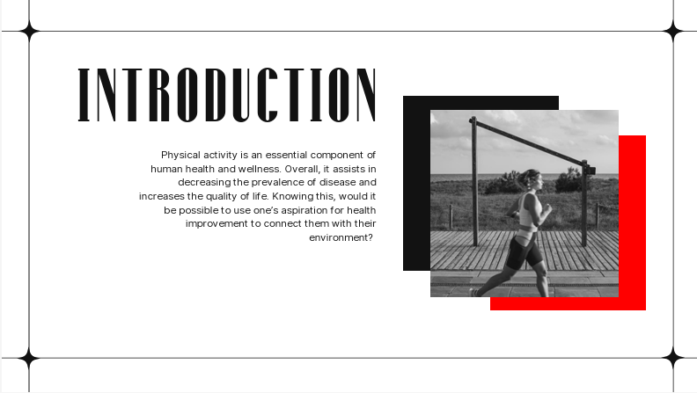

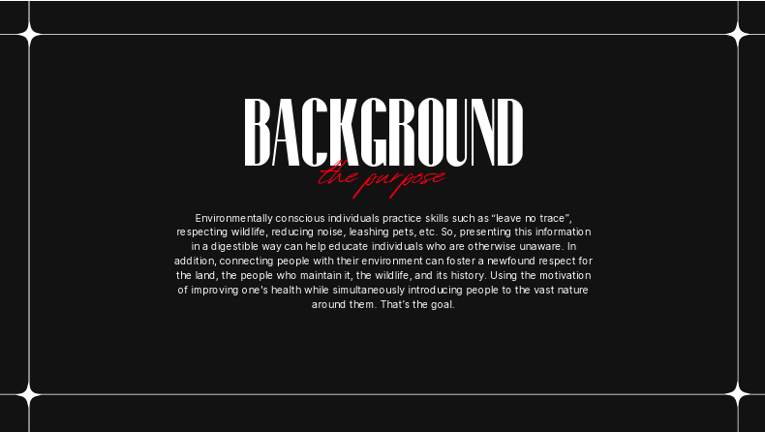

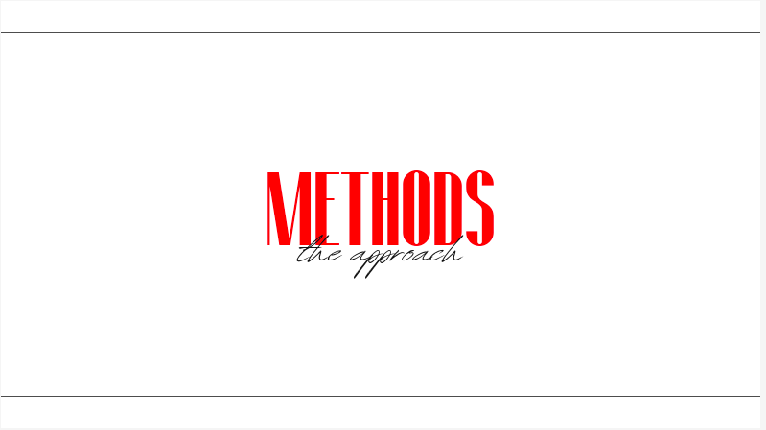

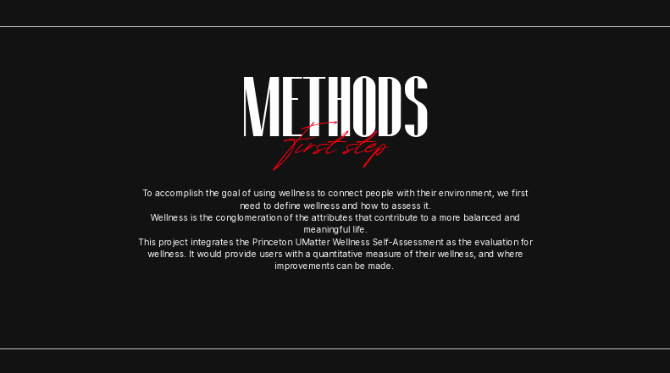

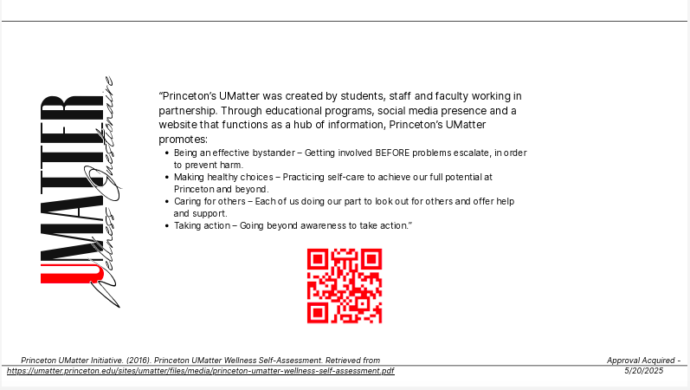

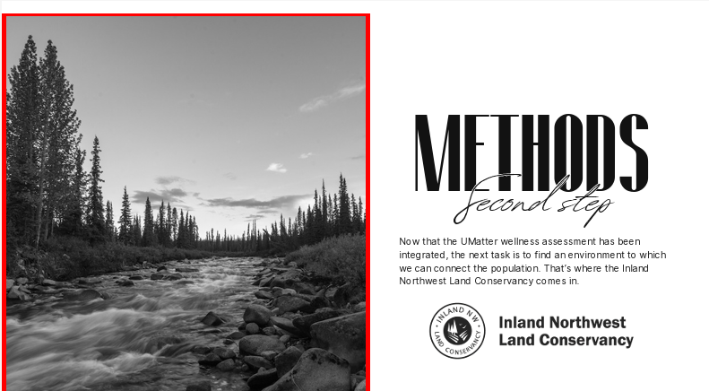

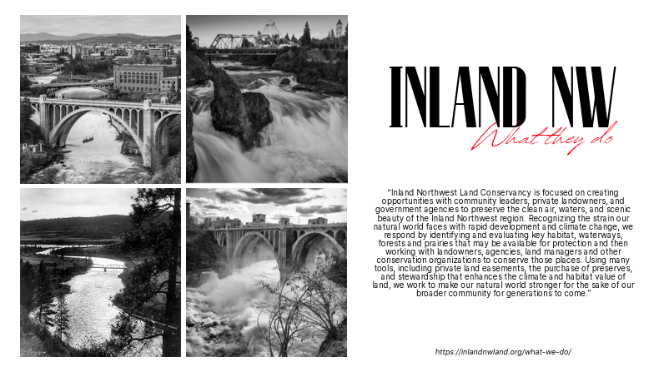

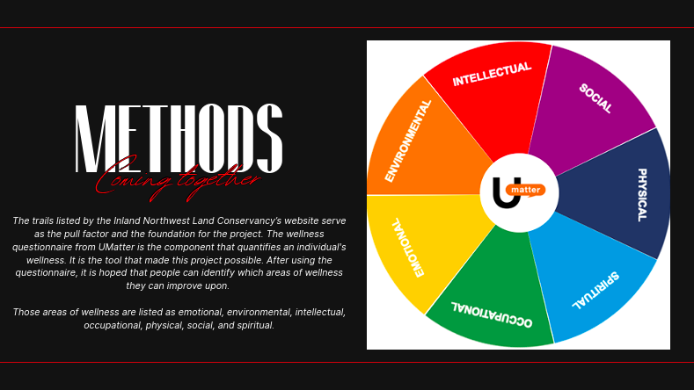

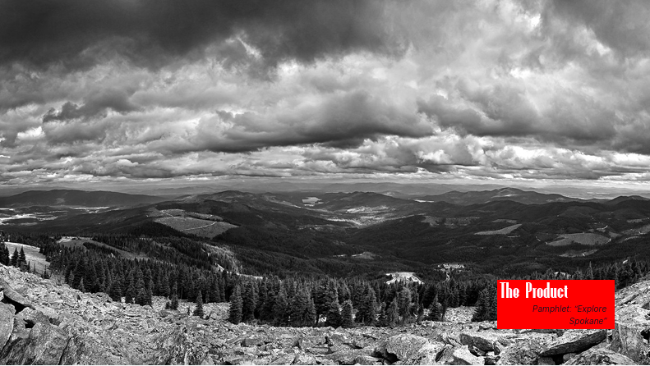

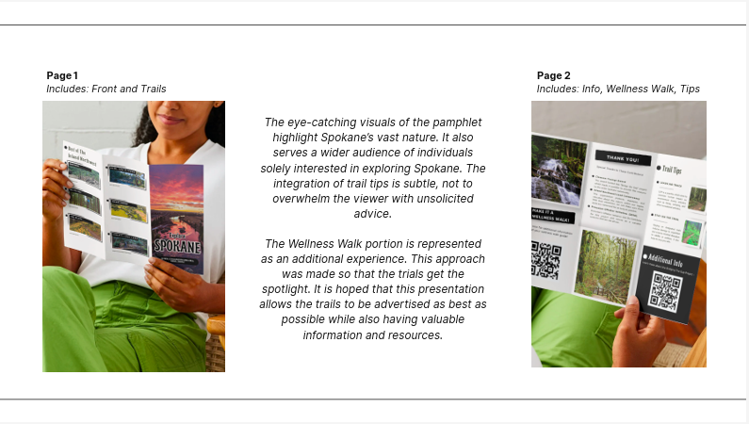



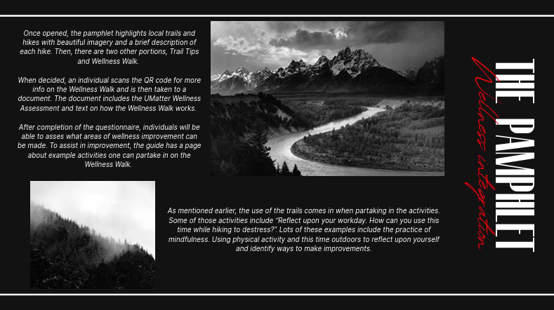

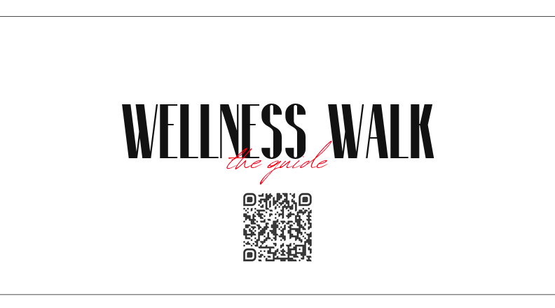

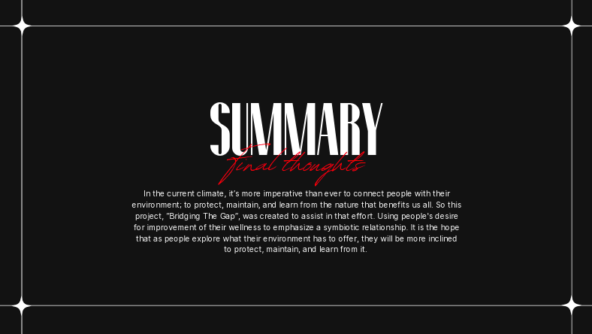

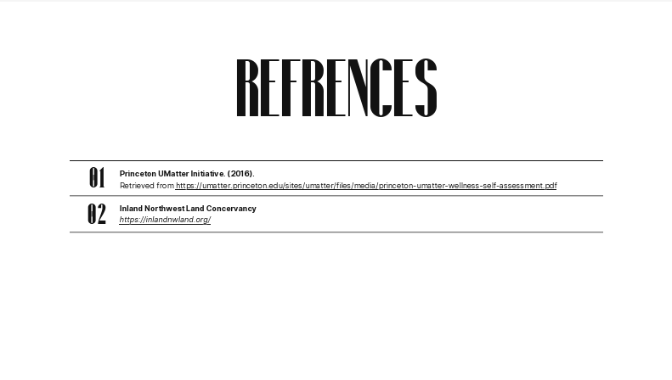



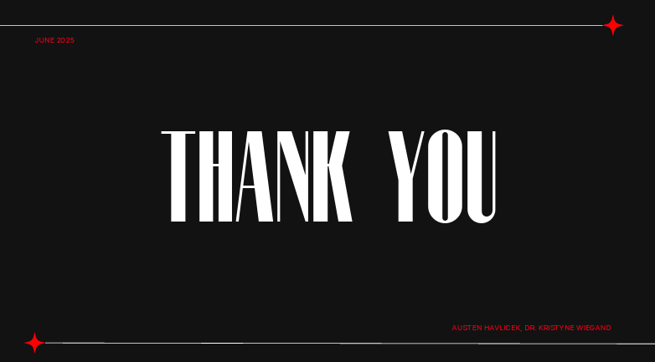

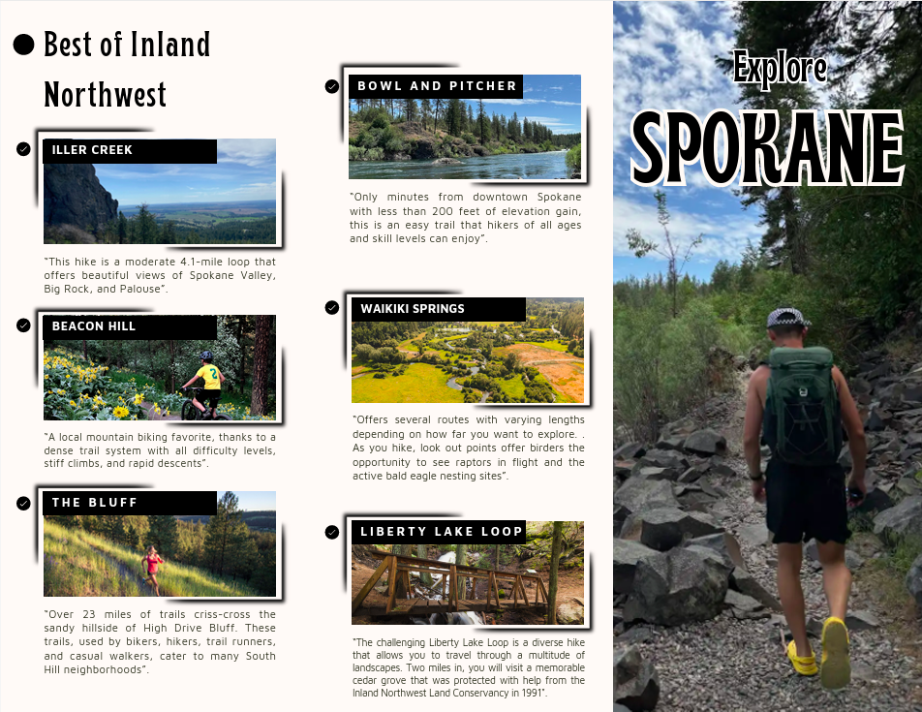

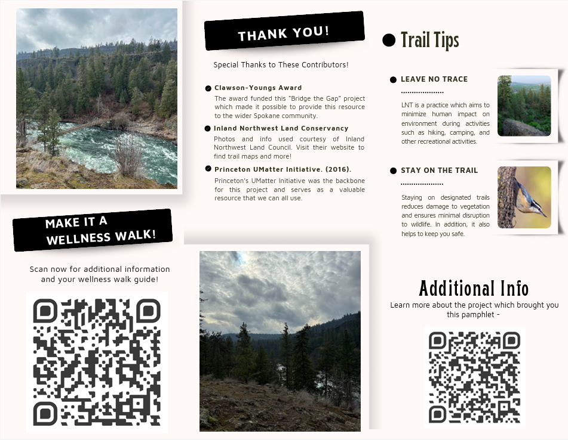

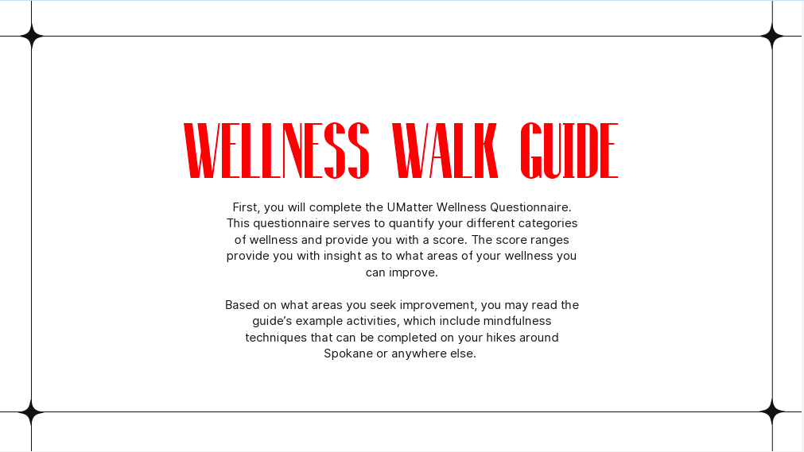

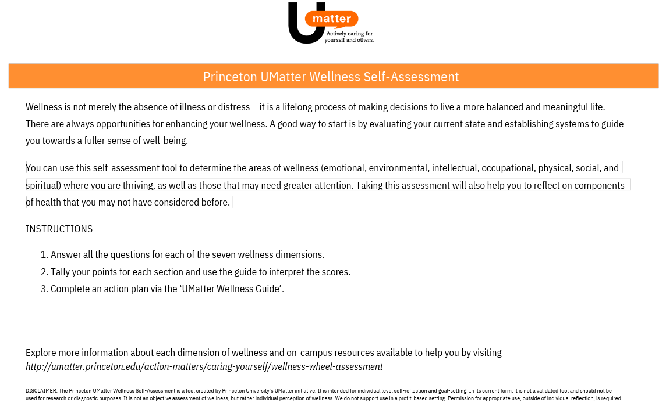
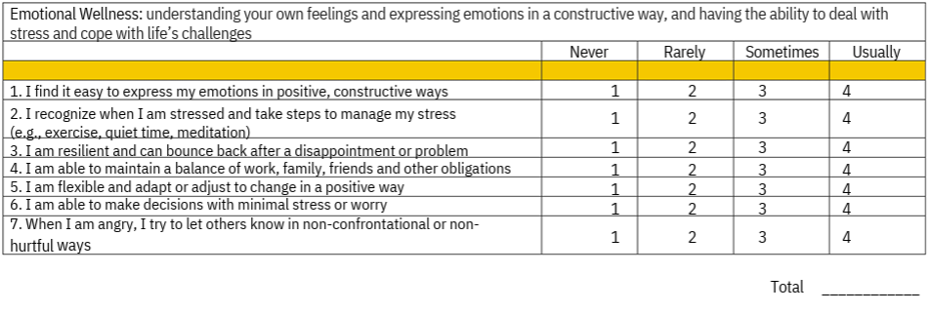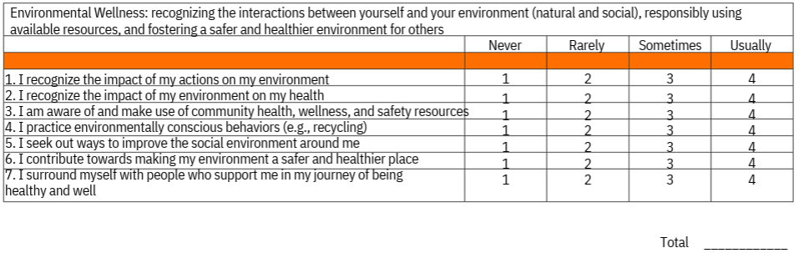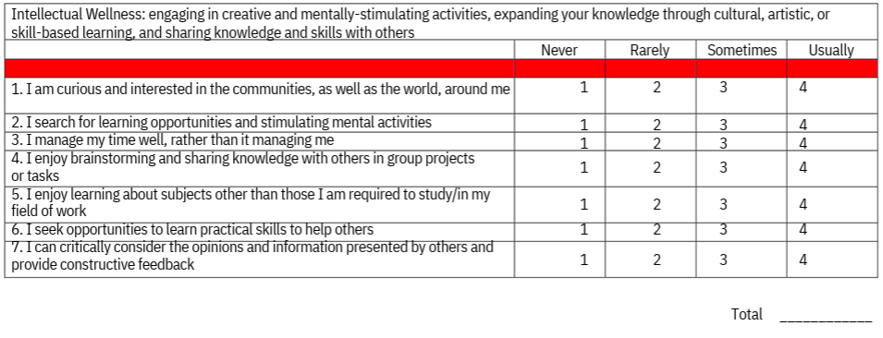

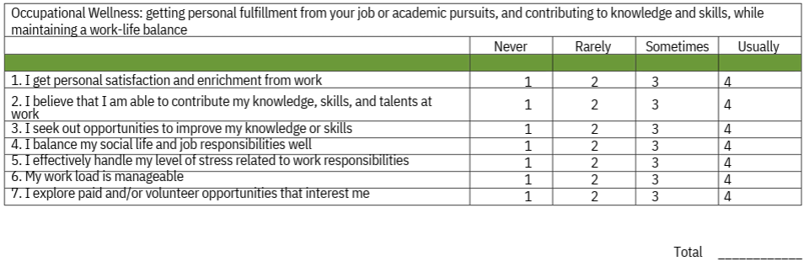
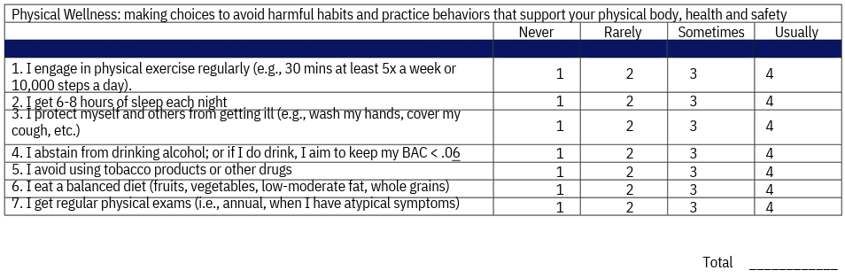
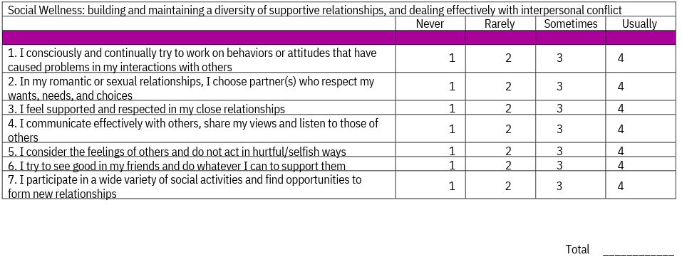
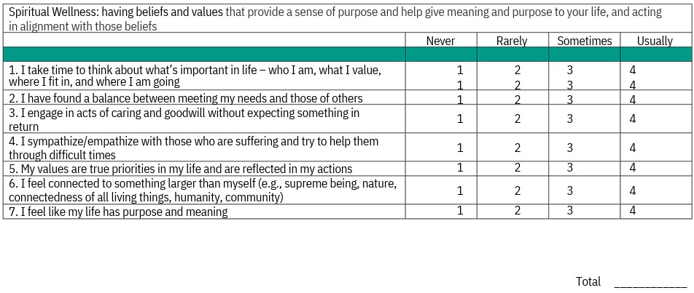

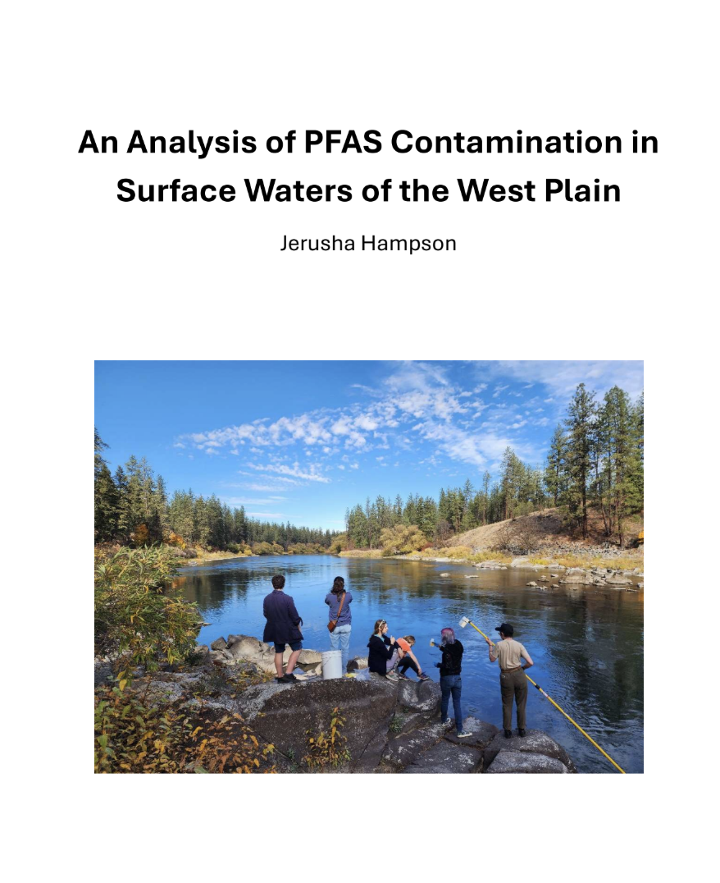

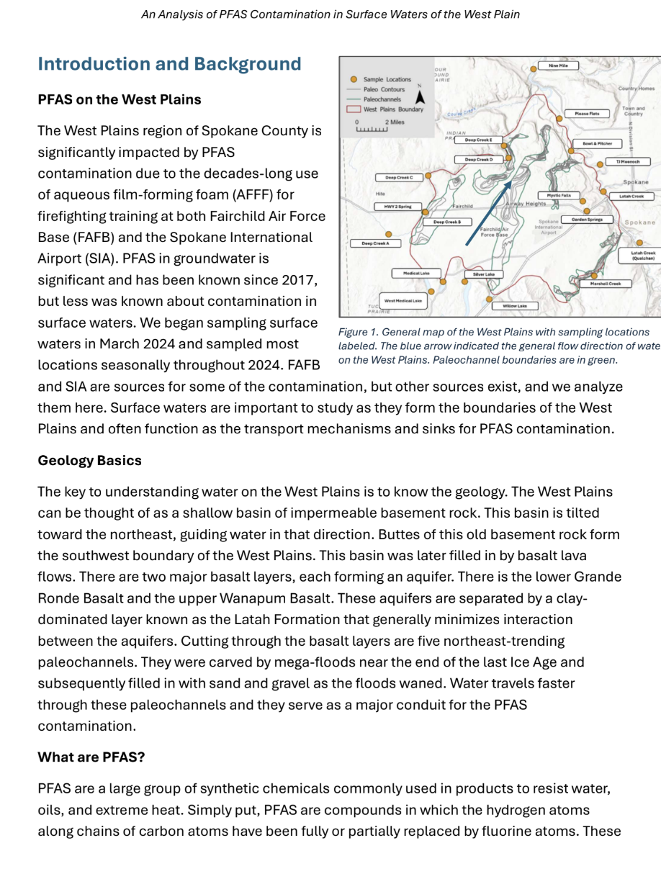

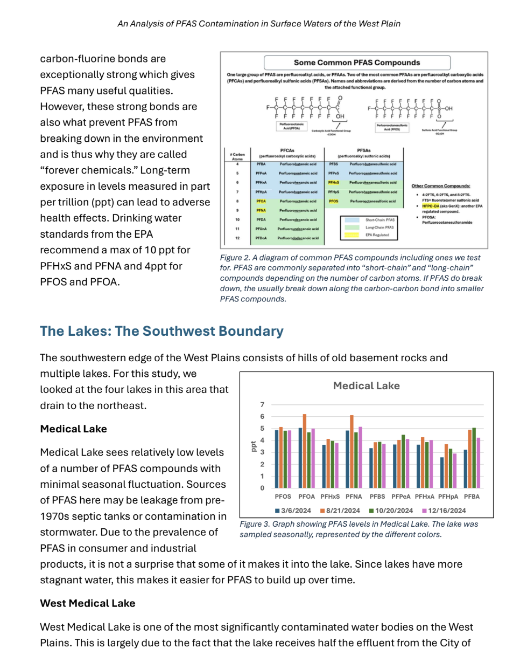

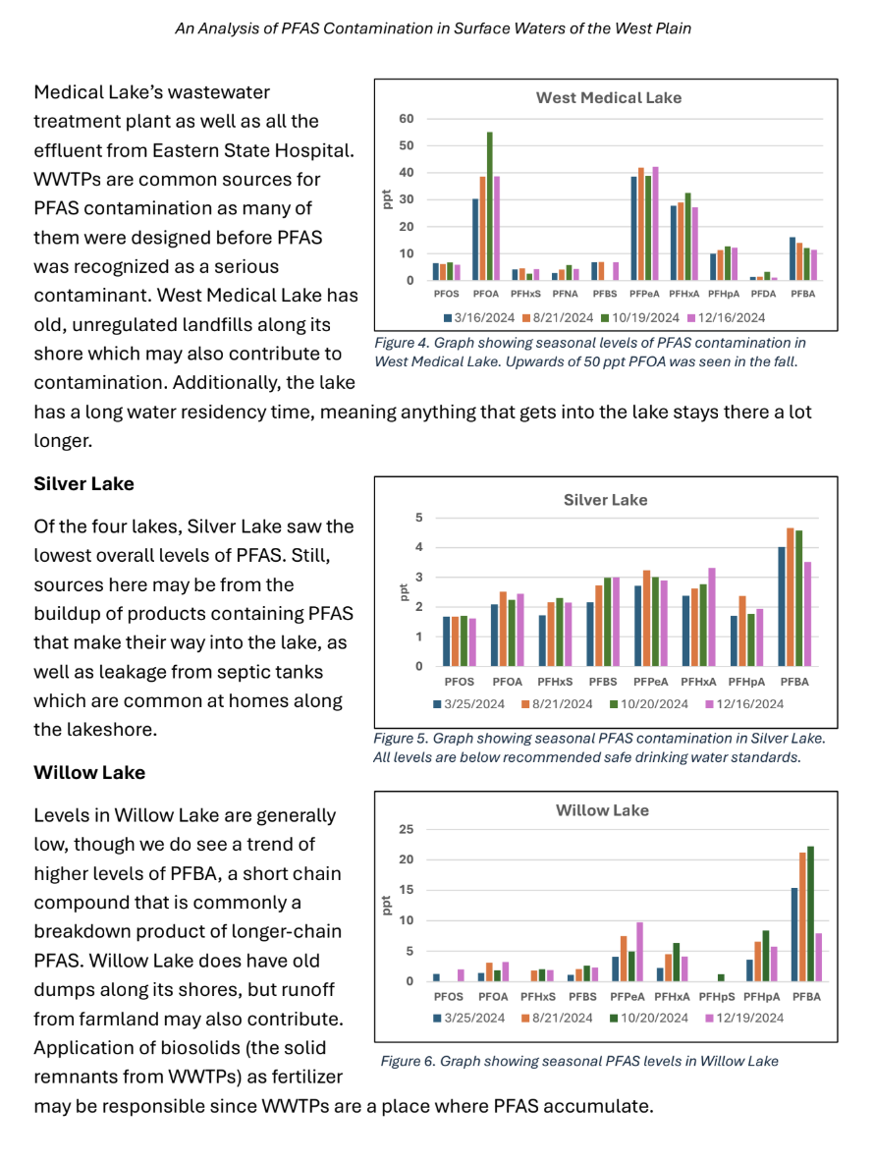

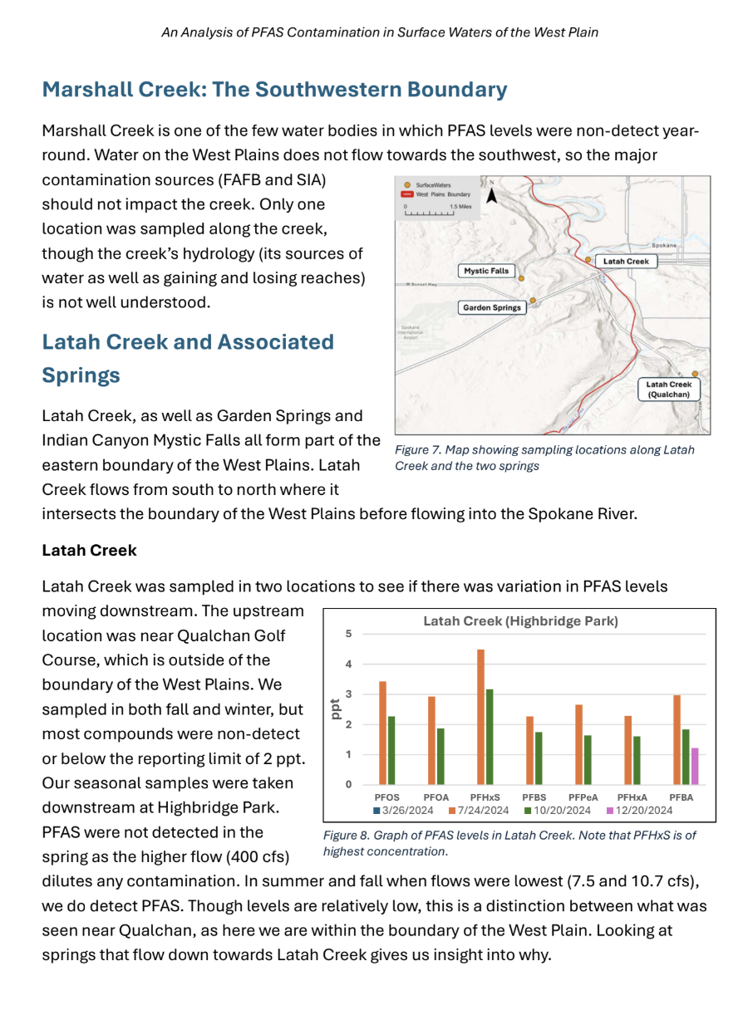

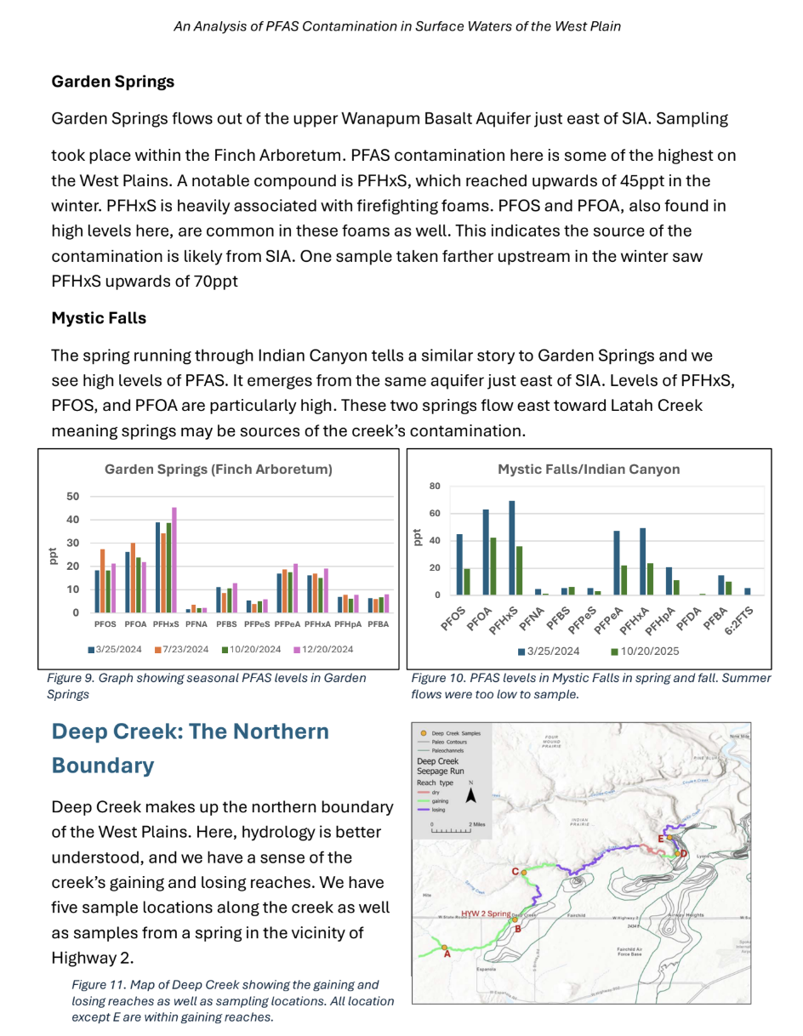

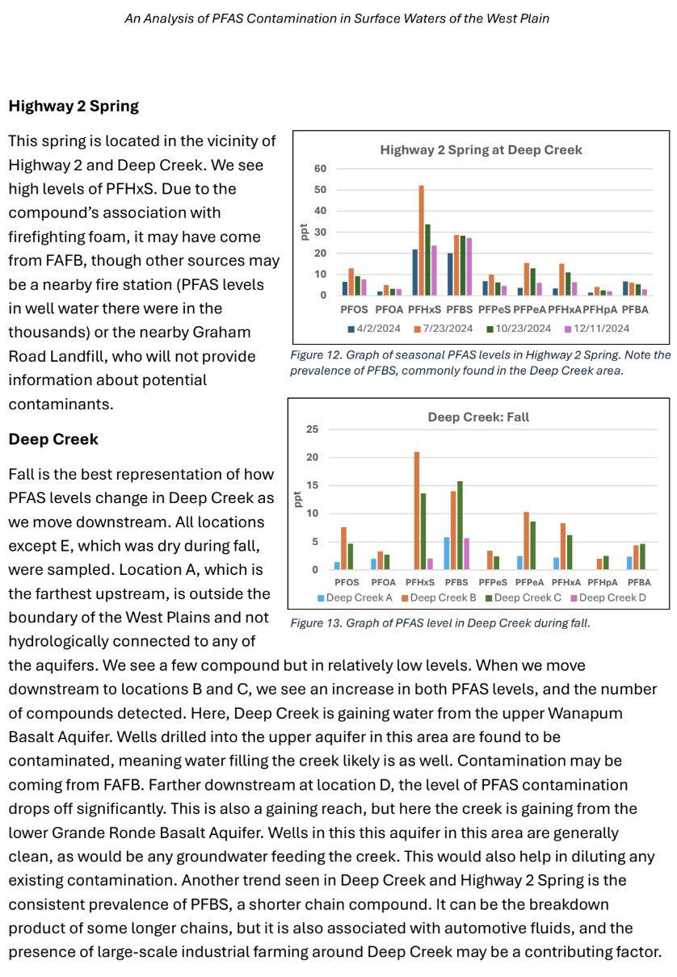

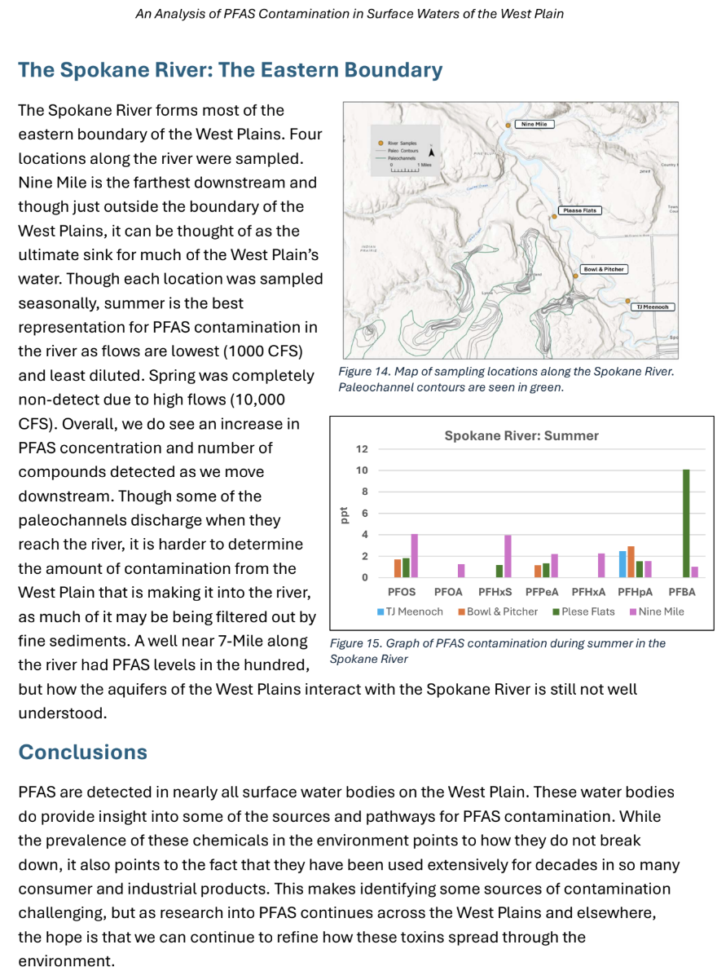

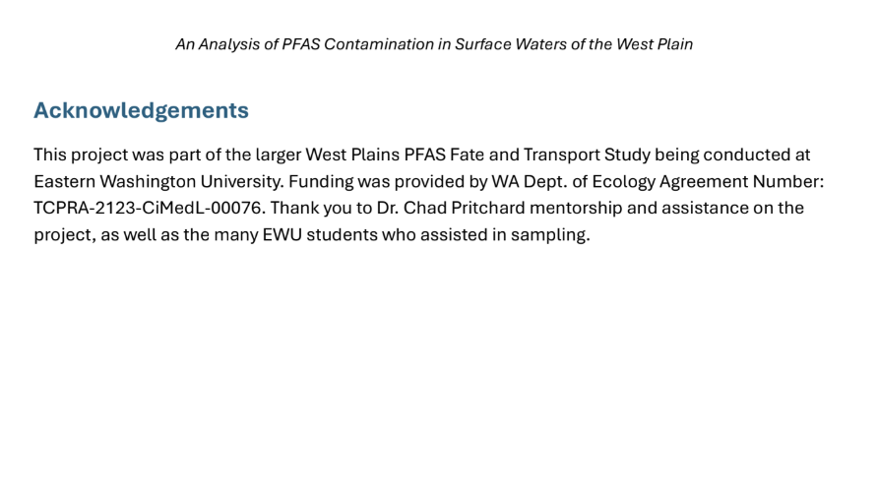

Tara Kelsey
Making Environmental Practices Accessible to Immigrants and Refugees

I am Tara Kelsey, a senior at Eastern Washington University currently studying Spanish for Education and English as a Second Language with a Linguistics minor. My degrees have opened doors into many cultures that have given me a deeper insight into the world. Firstly, it allowed me to travel into the heart of a culture I have studied for so many years, Spain. I was able to study abroad in Salamanca, Spain in the summer of 2024 where I experienced culture shock for the first time. This then led me to work with newly arrived refugee and immigrant students in an after-school program with the organization Refugee & Immigrant Connections Spokane (RICS). Through these experiences, I have seen first-hand just how hard it can be to live in a culture different from your own which inspired me to develop English as a Second Language (ESL) learning activities centered around sustainability to create a new pathway of learning early in a newcomer’s time in the U.S.
Imagine you had to flee your country with nothing: no money, no clothes, no food. To add to the stress, you are entering a new country that you know hardly anything about-including what environmentally sustainable methods look like in the new country. That is what immigrants and refugees face every day. Instead of waiting until they know a “sufficient” amount of English, we need to teach them about our systems from the beginning. This will not only benefit them, but the overall well-being of our society as well. We can accomplish this with the help of ESL methods and a few learning activities. More specifically, the activities that I have developed will teach them about our recycling systems, how to consciously consume water/food, our littering policies, and the prevalence of second-hand stores and food pantries. Using ESL methods will make learning about these topics accessible early in someone’s time in the U.S. Students are likely to share these ideas with their families and their communities which would benefit our general society as well.

I first started with basic ideas about conscious consumption and recycling systems then through research I was able to fully develop 5 activities. Each activity focuses on a different topic/culture shock that is a common obstacle for refugees and immigrants. The first one teaches about food consumption by introducing a variety of fruits/vegetables for them to try and decide whether they like them or not. This is also an opportunity for them to learn about the use of food pantries and see an example of composting. The second teaches about trash systems through a guessing game of how each type of trash should be disposed of. This seems simple, but it can be a very difficult topic for those from countries with different systems than ours. It can also teach them about our littering policy which is very beneficial for those from countries where litter is common and permitted. The third promotes reusing clothes by teaching about thrift stores and how they are commonly used in the U.S. In many countries, wearing used clothes can be frowned upon, so it is helpful for them to learn that it is acceptable. The fourth teaches them how to plant seeds (herbs, fruit, vegetables) and care for them. This allows them to take home their plants for their families to use. Finally, the fifth one demonstrates ways to reduce our energy consumption. For example, how turning off the sink while brushing their teeth, taking shorter showers, and turning off the lights will help us save energy. Many of our resources in the States are new to refugees and immigrants, so they may not know how to use them properly without instruction.
After receiving the Clawson Youngs Award, I was able to fully develop these activities and create a poster presentation. I then got the chance to present my work at EWU’s Creative Works and Research Symposium. Thanks to the help of my mentor, Dr. Gina Petrie, my presentation displayed my activities through a format that identifies steps, materials needed, learning outcomes, ESL strategies, sustainability strategies, and cultural strategies. This presentation was a great opportunity for me to show my work to a wide variety of students, professors, and community members. Through the use of this presentation, I felt that I was able to inspire many prospective teachers to implement these strategies in their classrooms in the future. However, I also had the privilege to speak with many immigrants of all different ages. Every one of them that I spoke to told me that they have struggled with many, if not all, of the culture shocks that my activities focus on. They also expressed that they wished they had this knowledge in the beginning to help them with their transition. Talking with them was very powerful and helped confirm the need for my project. It encouraged me to continue my work and research ways to implement it in our society.
Since my presentation, I have continued volunteering with RICS. I plan on continuing my research on the struggles the students encounter and implementing more of my activities into these after-school programs. As well, I am currently in the process of giving the activities I have formed to Barton English Language School to use in their classes. This is a non-profit organization focused on teaching English to adult students, particularly those who are a part of the international community in Spokane. I hope by doing this I will be able to spread the need for sustainability activities and help reduce the struggles of newly arrived refugees and immigrants. As I move forward with these steps and continue my research, I have the intention of presenting at the 2026 Spokane Regional ESL Conference.

Emily Ladd

Fire Scars

Mushroom hunting is a damp affair. I wear my canvas overalls, the backside permanently stained black from climbing over fallen logs. The clouds hang low over the Panhandle National Forest, high above Kellogg and Wallace. It’s cool enough to want long sleeves, but it doesn’t take a lot of crouching and shuffling before I sweat through my shirt.
The first year I went morel hunting with my dad and his wife, in spring 2021, we struck gold. Over the course of three or four hours, we picked thirty pounds of mushrooms. I still have a few quart bags hiding in the corners of my freezer.
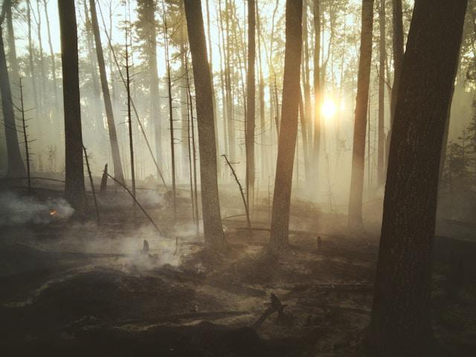
In North Idaho and Eastern Washington, the black morel (Morchella elata) springs up in patches from April through June, depending on what kind of spring we’re having. The mushroom’s mycelium creep, unseen, beneath the disturbed soil following logging operations. Their pointed caps pop up, seemingly from nowhere, the dark ridges disguising them against the backdrop of bark and pine needles. They prefer temperatures above freezing, but below seventy. They can be found in waves, following the thaw up the mountainside. They’re more likely to put up fruiting bodies—the part we humans like to eat—after a good spring rainfall.
Landon Parenteau. 2021.
And, more than anything, morels grow best in scars: whole swatches of forest desolate and black from a previous summer’s wildfire.
-
When I was a child, forest fires were an abstract, amorphous concept. They were no different than “the office”—places my father went when he wasn’t home. Except forest fires would draw him away for weeks at a time, the way my friends’ fathers might disappear for business trips.
In second grade, we discussed a classmate’s anxieties over her father’s eye surgery, the potential for the operation to go awry and cause permanent blindness. We shifted from talking about that father directly to my own, and for the first time it clicked in my mind that wildfires are synonymous with danger.
There are four key ingredients for extreme fire conditions: low humidity, strong winds, drought, and humans. Over eighty percent of forest and wildfires are caused by humans—by our utilities or negligence.
Following one dry summer, strong winds in Spokane County downed power lines and fanned multiple fires that left local and state fire teams scrambling to contain them. Over the next few days, over 110 homes were lost and two people killed. The local fire department pulled people off the street, offered ten minutes of training, and sent them out to help fight the fires. Over the course of less than twenty-four hours, around eighty separate fires had sprung up across the region. The event became known locally as “Firestorm.”
It was October 1991. I was six months old.
-
On August 18th, 2023, I was working my retail job just north of downtown, when word spread about a fire outside of Medical Lake, the Gray Fire. Eastbound winds carried the smoke down Sunset Hill. Through our floor-to-ceiling windows, the store’s usual view of the city became a solid wall of gray.
That same day, a second fire started north of town, on Oregon Road, less than a mile from where my grandmother used to live in a single-wide trailer in Elk.
Between the two fires, two people were killed, 20,000 acres burned, and over 600 structures lost. It would take until September 1st for crews to contain the Gray Fire in Medical Lake, and the Oregon Fire would continue blazing until mid-September.
Both fires were man-made: one from an outdoor light owned by Inland Power and Light and the other from “improperly stored materials” on private property.
-
Our region’s relationship with fire goes back over a century.
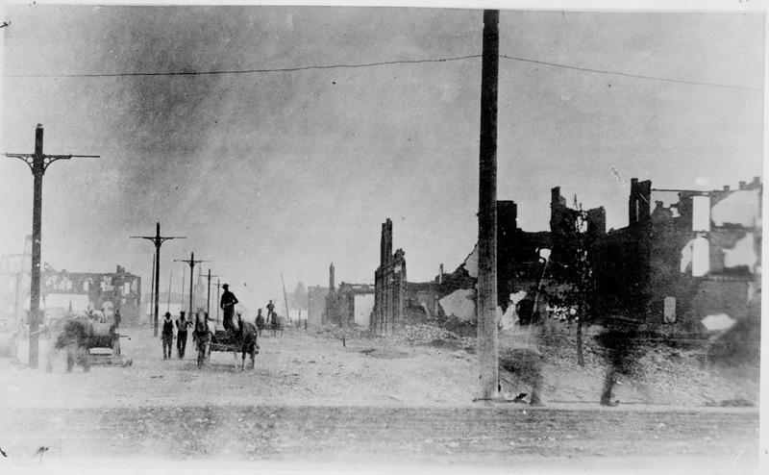
In 1889, the same year Washington became a state, separate major fires burned large parts of Seattle, Ellensburg, Cheney, Spokane, and Coeur d’Alene. Our fire that year, the “Great Spokane Fire,” eventually destroyed the entirety of downtown and could only be contained by demolishing buildings with dynamite to prevent further spread.
A short time later, the Great Fire of 1910 razed three million acres of forestland in Northern Idaho and Western Montana, killing eighty-seven people and destroying several entire towns in the process.
Spokesman Public Library. 1889.
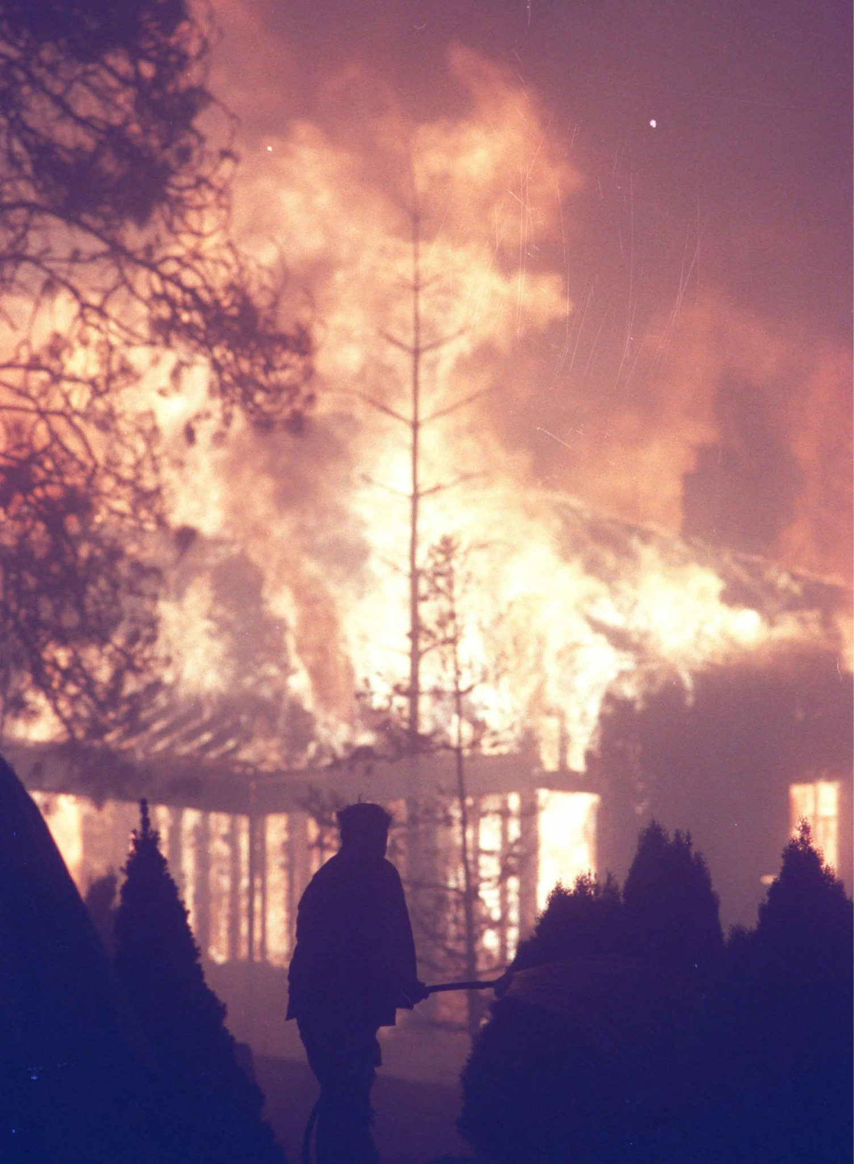
In 2008, two teenagers roasting marshmallows started the Valley View fire that spread through much of Dishman Hills and destroyed at least eleven homes. I remember standing on my front porch in East Valley, watching a pillar of gray-brown smoke split the cloudless sky in half.
1991’s Firestorm changed the way the state as a whole responds to fire. The Washington State Fire Services Resource Mobilization Plan was created to share forest fire teams across the state. Residents across the area are encouraged to have evacuation plans and go bags ready during fire season. But no level of preparedness has stopped new fires from springing up in the thirty-four years since Firestorm. It didn’t prevent the Oregon and Gray Fires.
-
Two days after the Oregon and Gray Fires started, Hurricane Hilary made landfall off the coast of Mexico. The storm was a Category Four, with wind speeds as high as 140 mph. Hilary killed four people in Mexico and left over 300,000 people without power. In the US, the storm caused upwards of $900 million in damages, making it the seventh most costly storm to hit the US Pacific coast. Hilary’s path across California coincided with a five-point-one magnitude earthquake in Ojai, coining the term “hurriquake.” The storm traveled up the west side of the country, leaving a trail of destruction in its wake.
Spokesman Review. 1991.
Ironically, when Hilary reached Spokane County, weakened as it was by then, the rain was the only reason local fire crews were able to gain traction on containing the fires. The Gray Fire went from 10% to 48% contained in less than 48 hours.
-
It usually takes us a few trips to get our timing right for morels in the Panhandle National Forest. The roads we drive up are winding and steep, climbing steadily higher into parts of the forest rarely explored in the late spring. Sometimes there’s still snow, the ground too cold for mushrooms to survive. Other times, the conditions appear correct, the air moist and lightly warm and the ground fully thawed, but we still struggle to find morels, even in the fire scars.
Some springs we wander through the charred corpses of trees with nothing to show for it.
-
Fire isn’t innately problematic in nature. Forest fires can be a good thing. In every part of the continental US, forests and prairies should experience recurring burn cycles that help the ecosystem thrive. Occasional, low-intensity forest fires clear out the overgrowth and help release nutrients in the soil. In some cases, these fires are crucial for keeping out invasive species and allowing the natural grasses or trees of the area to thrive.
In the Ponderosa forests common across Washington, lightning strikes should cause fires to sweep through every five to twenty-five years. In the mountains of Northern Idaho, nature’s schedule is closer to every eighty to three hundred years.
The key here is low-intensity. If the natural fire cycle is interrupted, undergrowth builds up and, when fires do occur—naturally or otherwise—they burn long and hot enough to kill all species caught in them, including humans.
-
For people like me, Spokanites born and raised, fire feels like both our birthright and our destiny. In many other parts of the world, the frequency and severity of natural disasters continues increasing due to human-inflicted climate change. But those catastrophes are still considered “Acts of God,” triggered by a series of conditions on a global scale. Our fires can be traced back to specific human actions: ignoring burn bans, failing to maintain our utilities, allowing our natural spaces to grow denser than nature would historically allow.
We head into summer with a lingering sense of dread. Will this summer be like 2021, when temperatures in Spokane regularly reached 110° and higher? It seems each year the area gets less and less rain, and the opportunities for fires to ignite and spread uncontrolled continues. The 2023 Gray Fire was started by a lightbulb.
My father is retired and no longer spends his summers working forest fires.
I hang on to my fabric masks from the pandemic, both for when I catch a cold and the days when the air outside is too filled with smoke to breathe safely.
Spokane’s years are divided into two seasons: fire season and winter. Each year, the winter season becomes shorter and its counterpart longer. Burning is a symptom of humanity. This is our inheritance and our responsibility. The kitchen’s on fire, and we’re the ones who lit it.

Daisy Roberts
Young Stewards: Scouts in Action for Nature

Summary:
Environment Day was a Cub Scout activity held at Turnbull National Wildlife Refuge for a few hours on May 10. Cub Scout Owen came and earned his Champions for Nature Adventure by building a solar-powered s’more oven, putting together a compost jar, planting native plants in planters, learning about renewable resources, and speaking with a recycling professional from Action Recycling. I had two volunteers plus myself helping with the event. Owen and his mom learned about topics they are taking home to share with his younger sister and adding to their homeschool curriculum. I was able to reaffirm my passion for helping with the Boy Scouts while learning valuable lessons for next time I organize such an event.
Preparation:
Firstly, I needed to get a headcount on participating scouts. A marketing coordinator at the Boy Scouts gave me advice on creating a flyer to advertise my event to scouting families. After reaching out by phone and email to seven local packs, three responded and sent my flyer to their pack families. Four scouts were RSVP’d to attend, and Environment Day was on!
Scouts, check! Next up, location. The Visitor Services Manager at Turnbull National Wildlife Refuge gave me permission to use one of the gazebo areas. Turnbull is the perfect place to teach scouts about the importance of native plants, such as the coneflower and lupine we made planters for.
As I was not connected to a club, I was not allowed to post flyers on campus for my planned recycling drive. But that didn’t stop me from getting EWU and my community involved with Environment Day. I advertised by word of mouth to the full-time and student employees of Sutton Hall, who collected glass sauce jars, soda cans, and glass soda bottles for the compost jars and resources relay race. The Grain Shed donated pizza boxes to use for a solar-powered s’more oven, a fourth-grade teacher at Windsor Elementary donated a bag of crayons for the coloring station, Ace Hardware in Cheney donated a bag of potting soil for the planters, and a student in the creative writing department donated a bag of dirt from her backyard for the compost jars.
Aside from the people and businesses who donated materials, I needed volunteers to help during the event. I emailed the biology, geosciences, education, environmental science, and creative writing departments, who sent out my flyer and information to their students. Aidan and Piper, two creative writing students, were present throughout the entire event, taking photos, educating about invasive species, and participating in coloring, planting, and the relay race. A requirement for the Champions for Nature adventure is to speak with a recycling professional, so after reaching out to different recycling places in Spokane, Action Recycling sent Glen Ahlborn to speak with us.
The final weeks leading up to the big day were filled with research, writing, and listening to my favorite nature sounds background music as I put together activity kits. I researched renewable resources, endangered species, and composting to be able to answer any questions the scouts would have, wrote instructions for the volunteers so they could be involved with each activity, and saved and froze compost materials like espresso grounds, eggshells, newspapers, apple cores, and banana peels for the compost jars. I put kits together for the s’more oven, compost jar, planters, and resource relay race. I also sent out a reminder text and email to the families who RSVP’d.
Day of the Event:
On May 10, volunteers arrived early to help set up for the sign-in station, coloring station, and resources relay race. While we were expecting four scouts, only one scout and parent showed up. Both the attending scout mom and I texted the absent families but unfortunately, we didn’t get a response. Although this was disappointing, I am grateful to have been able to provide one-on-one attention to Cub Scout Owen to help him earn his award.
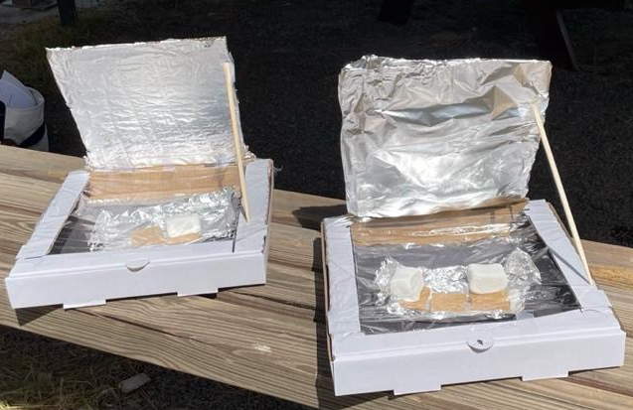
Owen was the perfect participant for Environment Day. He was inquisitive, interested in the environment, and soaked up everything we taught him. He was excited for each project and jumped into each activity without hesitation. He was enthusiastic and eager to make the s’more oven, from which he was able to enjoy a sun-cooked smore a half hour or so later. Owen was also observant, pointing out different species of birds at Turnbull during our nature walk.
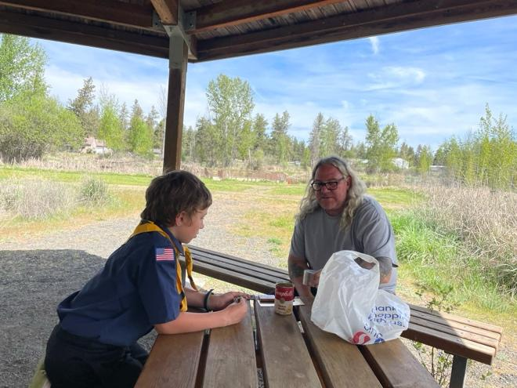
Glen Ahlborn from Action Recycling brought different kinds of metals, like gold from a computer chip, a tin can, silver, brass, etc., and a magnet, to show a small-scale process of what happens at a metal recycling place. He also talked about how important and easy it is to recycle and what happens with the different kinds of metal after they come to him. Both Owen and the volunteers had lots of questions for him, which he answered thoroughly.
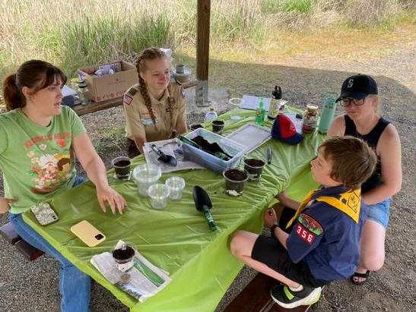
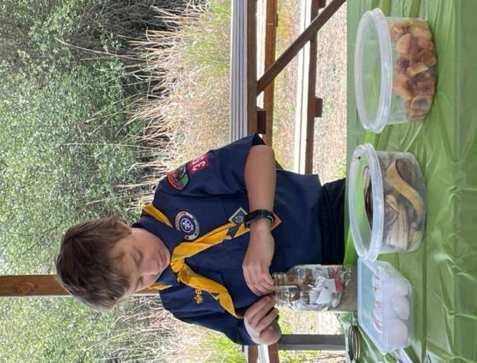
We made compost jars in glass sauce jars, talking about how we can reduce biological waste from our kitchen and use it in our gardens. In small planters, we planted coneflower and lupine, which are native plants, for Owen to take home and put in his garden. We talked about how he can use the compost from his jar in his planter. When talking about native plants and invasive species, Owen was very interested. One of the volunteers, Piper, is a fellow Clawson-Youngs Award winner, writing an essay on invasive species, so she was able to answer Owen’s questions in depth.
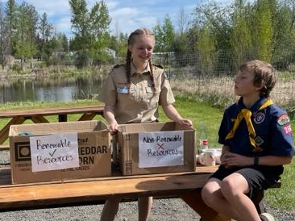
Another way volunteers played an active role in the event was by participating in the resource relay race alongside Owen. We split into teams, boys versus girls, and raced to sort renewable and non-renewable resources, like an aluminum can versus a cotton t-shirt. After sorting into boxes, we talked about each of the twenty items to make sure Owen understood the difference.

Outcomes:

I am pleased with the impact the event had on Owen, his mom, my volunteers, and me. First, I am excited to share that Owen has earned his Champions in Nature Adventure, which means he gets to add a new red belt loop to his scout belt. Secondly, Owen is homeschooled, and since he was so interested in learning about native and invasive species from Piper and I, Owen’s mom is planning on incorporating lessons on the topic into his curriculum. Thirdly, Owen is excited to try out different solar-powered oven recipes with his younger sister like quesadillas or cookies. I have reenergized my passion for the Boy Scouts, solidifying the fact I want to volunteer on a regular basis with a troop starting this summer. This experience affirmed to me the importance of helping kids learn about topics that interest them through crafts, question and answer discussions, and outdoor play. As far as environmental education in my own life, I am excited to use compost jars for my own plants and porch garden.
I also had some takeaways for what I would do differently for when I volunteer in the future. If I had gone in person to a pack meeting to advertise, I believe there would have been a higher attendance. I was not able to do that this time around, as I had class conflicts with pack meeting days. I would also focus on all age groups of one pack, instead of one age group across multiple packs, and offer to hold the event on the day of their regularly scheduled meetings. I cannot control people wanting to come, and I cannot control people not coming up after saying they would, but next time I do an event like this, I will be sure to make it easier for people to be there.

Sarah Rooney

Follow-Up Report for Clawson-Youngs Project: Community Hike, Trail Clean-Up, and Open Mic Event
Event Overview
In response to the initial proposal for a community-centered event blending environmental stewardship and creative expression, we successfully hosted our event. It was a hike, trail clean-up, and open mic on April 26th from 2:30–5:30 PM at People’s Park near the Spokane River. The event brought together 30 enthusiastic participants, all of whom contributed to both the clean-up efforts and the creative performances that followed.
Partnerships & Support
We were proud to partner with Spokane Riverkeepers, who not only supported the clean-up but also expressed interest in future collaborations. Their presence helped lend ecological context to the importance of our stewardship efforts. Jules Schultz provided an informative overview of what the Spokane Riverkeepers do as well as the historical context of the location we chose for the clean up.
Additionally, we teamed up with Conifriends, a local startup nonprofit dedicated to environmental action and education. They generously provided free native saplings for attendees to take home and plant, extending the event's impact beyond the trail and into participants’ neighborhoods and yards.
Creative Outcomes
After the clean-up, we hosted a full open mic event with a mix of scheduled and spontaneous performances. The creativity and vulnerability shared reflected a strong connection to the landscape and the shared experience of caring for it. Performers included both experienced readers and first-time speakers, echoing the inclusive spirit we aimed to cultivate.
While we had initially hoped to compile a zine from creative submissions, we did not receive enough material to produce one at this time. However, the enthusiastic feedback and the quality of work shared suggest strong potential for future contributions. We hope to collect submissions from future events throughout the year and eventually publish a collaborative zine by year’s end. Proceeds from zine sales are planned to benefit the Spokane Tribe, reinforcing our commitment to land acknowledgment and reparative action.
Looking Ahead
Building on the success of this event, we are planning to host similar gatherings quarterly, rotating through different trail locations in the Spokane area. This model will allow for diverse ecological engagement while building a larger archive of creative responses for future zine publication.
In July, Foray is scheduled to hold outdoor readings that we aim to pair with land stewardship and trash clean-up efforts, continuing this blend of environmental and artistic action.
An unexpected and inspiring outcome of the event was local writer Dave Klenda’s decision to partner with Spokane Riverkeepers for his book launch party, which also incorporated writing and environmental activism. This ripple effect underscores the potential of these events to foster deeper community connections and sustainable creative engagement.
Photos
The attached images document the event, including participants in a group photo and selected readers from the open mic. These moments capture the spirit of collaboration, environmental care, and expressive freedom that defined our afternoon together.
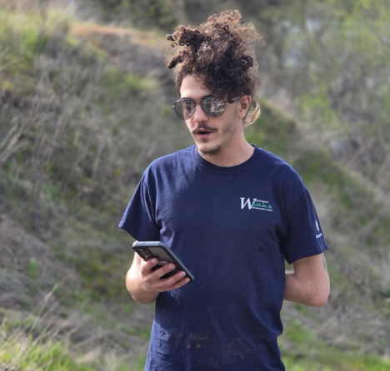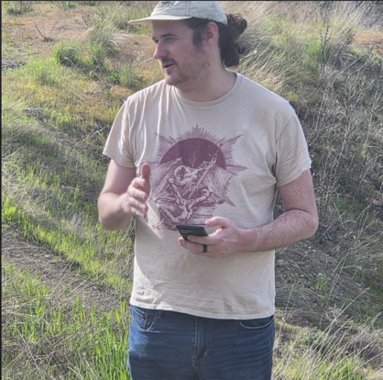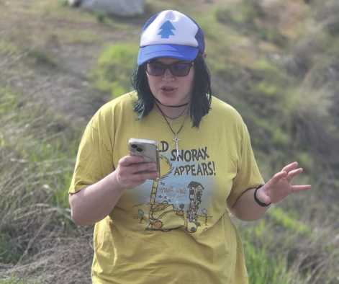
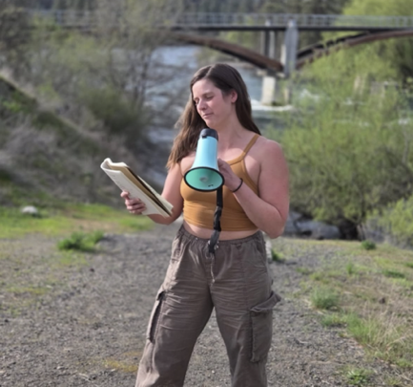
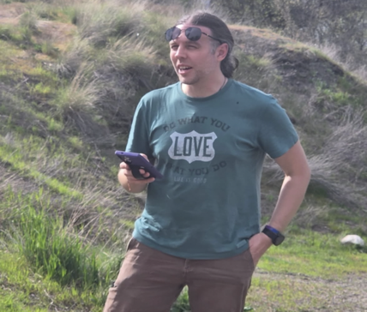
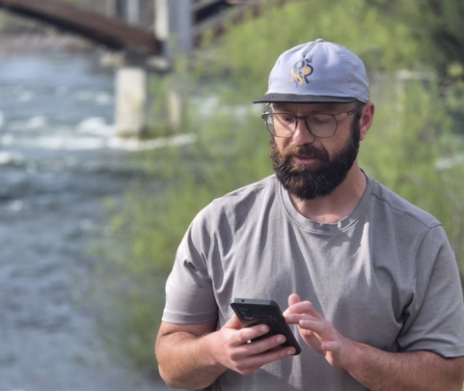

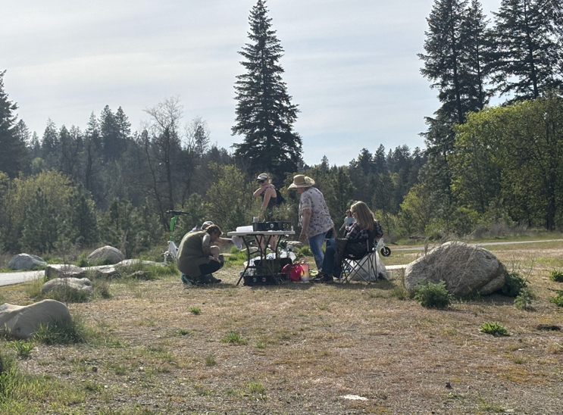
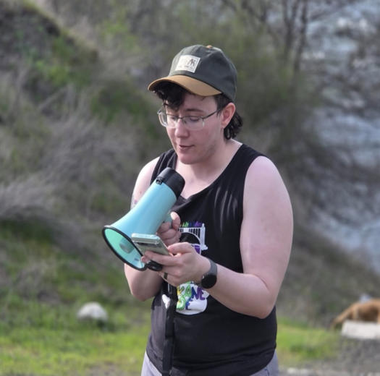

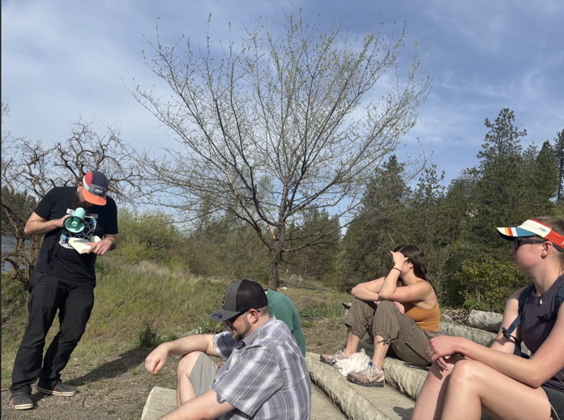
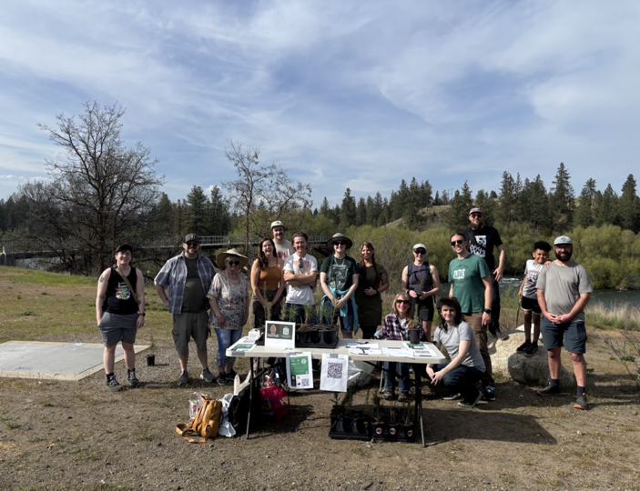

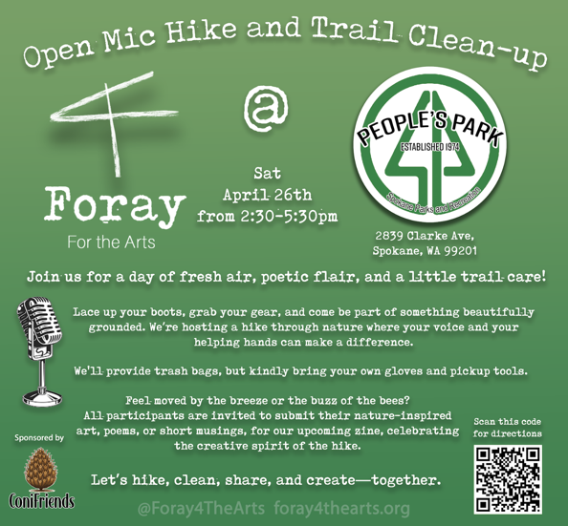

Conclusion
This inaugural event demonstrated that there is a growing appetite in our community for creative and ecologically-minded gatherings. We’re excited to build on this momentum with quarterly events, deeper partnerships, and a long-term vision of publishing a zine that uplifts local voices while supporting Indigenous communities. Thank you to all who contributed to making this event meaningful, memorable, and mission-driven.

